Works available by Luis Luna
18 May 2022

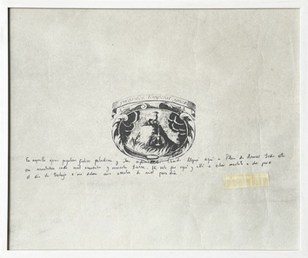 | Luis Luna  Carare Cordero Emblem, 2022  silkscreen and ink on paper  56 x 68 cm  22 1/8 x 26 3/4 in
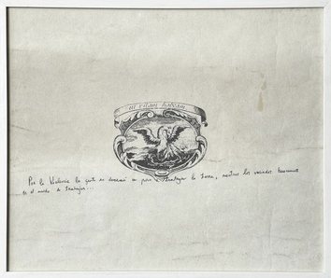 | Luis Luna  Carare Opon Emblem, 2022  silkscreen and ink on paper  56 x 68 cm  22 1/8 x 26 3/4 in
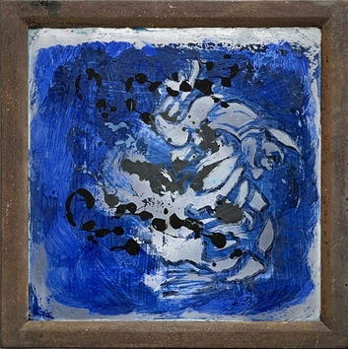 | Luis Luna  Celtic Tiger, 2022  enamel and oil on glass with metal frame  34 x 34 x 2 cm  13 3/8 x 13 3/8 x 3/4 in
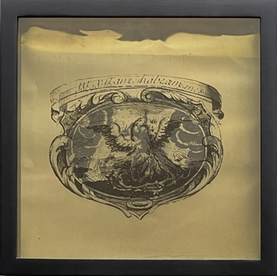 | Luis Luna  Barroque Emblem 1, 2022  silkscreen on bronze sheets and cellulose  32 x 32 x 7 cm  12 5/8 x 12 5/8 x 2 3/4 in
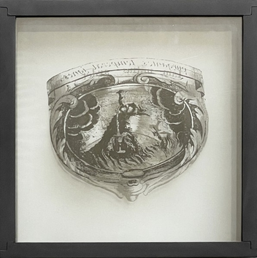 | Luis Luna  Barroque Emblem 3, 2022  silkscreen on cellulose asembled in glass  31.5 x 31.5 x 6 cm  12 3/8 x 12 3/8 x 2 3/8 in
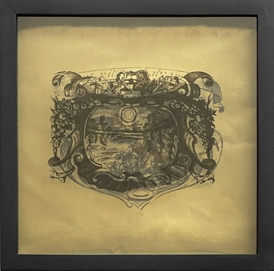 | Luis Luna  Barroque Emblem 2, 2022  silkscreen on bronze sheets and cellulose  31.5 x 31.5 x 6 cm  12 3/8 x 12 3/8 x 2 3/8 in
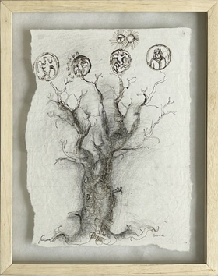 | Luis Luna  Oracular Tree, 2015  charcoal on paper  37 x 27 cm  14 5/8 x 10 5/8 in
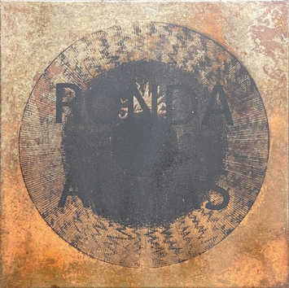 | Luis Luna  Ronda almas, 2014  silkscreen and oxide on metal  50 x 50 cm  19 3/4 x 19 3/4 in
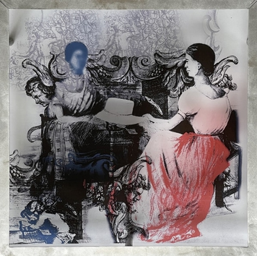 | Luis Luna  Hat Weavers, 2022  digital print on acrylic crystal  64 x 64 x 3 cm  25 1/4 x 25 1/4 x 1 1/8 in
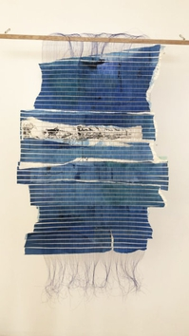 | Luis Luna  Travelers of the Nueva Granada, 2021  Oil on paper, nylon and metal threads and silkscreen.  130 x 100 cm  51 1/8 x 39 3/8 in
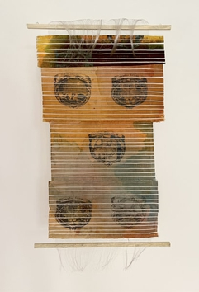 | Luis Luna  Emblem Series 4, 2022  pigments and silkscreen on canvas, woven with bronze and nylon threads  147 x 73 cm  57 7/8 x 28 3/4 in
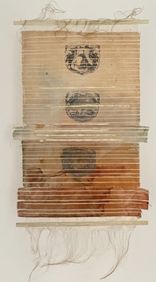 | Luis Luna  Emblem Series 2, 2022  pigments and silkscreen on canvas, woven with bronze and nylon threads  147 x 73 cm  57 7/8 x 28 3/4 in
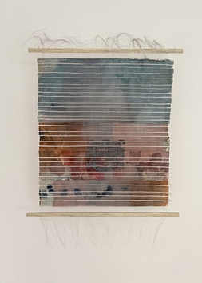 | Luis Luna  Emblem Series 3, 2022  pigments and silkscreen on canvas, woven with bronze and nylon threads  112 x 73 cm  44 1/8 x 28 3/4 in
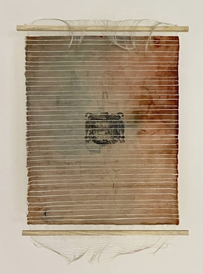 | Luis Luna  Emblem Series 1, 2022  pigments and silkscreen on canvas, woven with bronze and nylon threads  125 x 80 cm  49 1/4 x 31 1/2 in
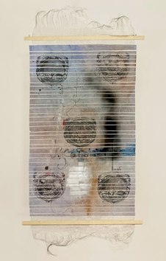 | Luis Luna  Emblem Series 5, 2022  pigments and silkscreen on canvas, woven with bronze and nylon threads  137 x 70 cm  54 x 27 1/2 in
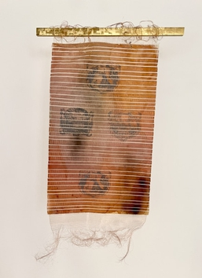 | Luis Luna  Emblem Series 6, 2022  pigments and silkscreen on canvas, woven with bronze and nylon threads  145 x 79 cm  57 1/8 x 31 1/8 in
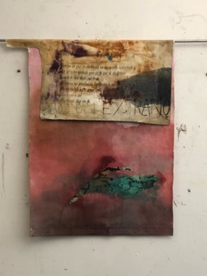 | Luis Luna  I Entered Like a Stranger, 2022  Assemblage - oil on canvas, silkscreen on paper and canvas collage sewn with hemp  98 x 84 cm  38 5/8 x 33 1/8 in
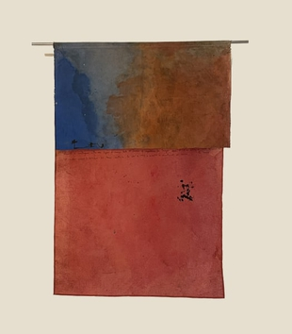 | Luis Luna  Spirit of the World, 2022  assemblage - mixed media on canvas  117 x 79 cm  46 1/8 x 31 1/8 in

