Works available by
13 March 2026

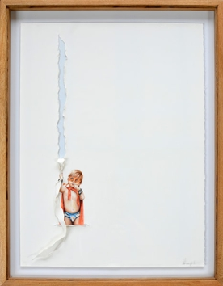 | Pablo Arrazola  Übermensch 31, 2025  Colored pencils on torn cotton paper  76 x 56 cm  29 7/8 x 22 in
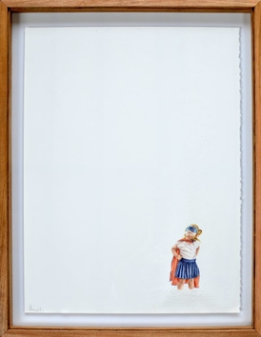 | Pablo Arrazola  Übermensch 24, 2025  Colored pencils on perforated cotton paper  76 x 56 cm  29 7/8 x 22 in
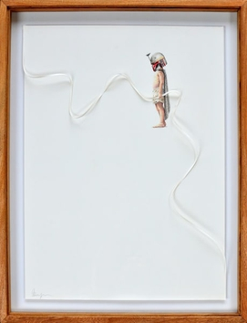 | Pablo Arrazola  Übermensch 40, 2025  Colored pencils on cut and folded cotton paper  76 x 56 cm  29 7/8 x 22 in
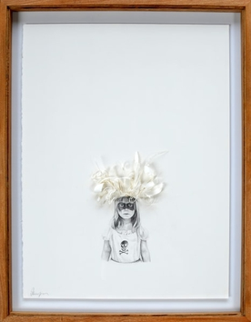 | Pablo Arrazola  Übermensch 34, 2025  Pencil on cut, torn and folded cotton paper  76 x 56 cm  29 7/8 x 22 in
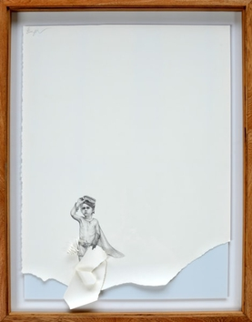 | Pablo Arrazola  Übermensch 37, 2025  Pencil on cut and torn cotton paper  76 x 56 cm  29 7/8 x 22 in
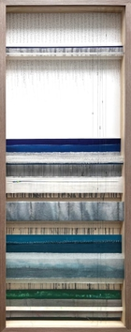 | Angelica Chavarro  Landscapes of Thought 24, 2026  Assemblage of intervened and mixed media canvases  141 x 56 x 8.5 cm  55 1/2 x 22 x 3 3/8 in
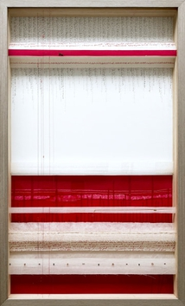 | Angelica Chavarro  Landscapes of Thought 25, 2026  Assemblage of intervened and mixed media canvases  101 x 61 x 8.5 cm  39 3/4 x 24 x 3 3/8 in
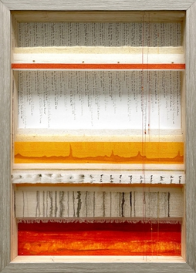 | Angelica Chavarro  Landscapes of Thought 26, 2026  Assemblage of intervened and mixed media canvases  50 x 40 x 7 cm  19 3/4 x 15 3/4 x 2 3/4 in
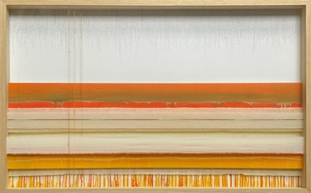 | Angelica Chavarro  Landscapes of Thought D, 2024  Assemblage of intervened natural fiber fabrics and mixed media  81 x 131 x 9 cm  31 7/8 x 51 5/8 x 3 1/2 in
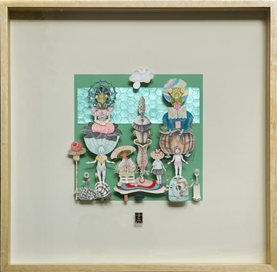 | Teresa Currea  Mothers and Daughters, 2026  Mixed media on cut paper and silver leaf  71 x 71 x 7 cm  28 x 28 x 2 3/4 in  XL
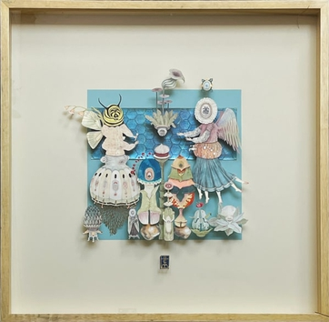 | Teresa Currea  Neither Too Much Nor Too Little, 2026  Mixed media on cut paper and mother-of-pearl foil  71 x 71 x 7 cm  28 x 28 x 2 3/4 in  XL
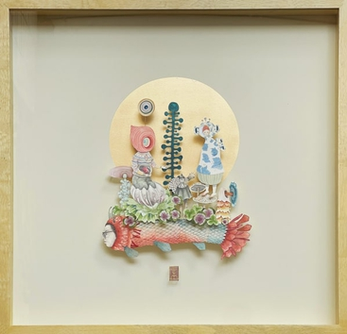 | Teresa Currea  The Messenger Angel, 2026  Mixed media on cut paper  71 x 71 x 7 cm  28 x 28 x 2 3/4 in  XL
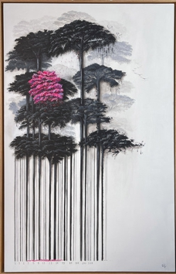 | Camila Echavarria  Jacaranda, 2025  Acrylic on canvas  161 x 101 cm  63 3/8 x 39 3/4 in
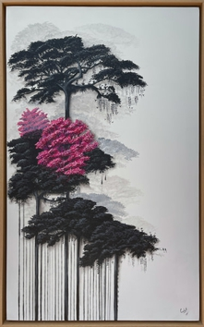 | Camila Echavarria  The Tree I Had Never Seen, 2025  Acrylic on canvas  101 x 61 cm  39 3/4 x 24 in
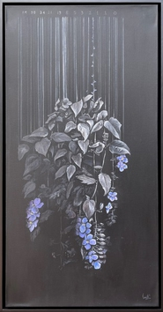 | Camila Echavarria  The Flower of the Bridges, 2025  acrylic on canvas  100 x 50 cm  39 3/8 x 19 3/4 in
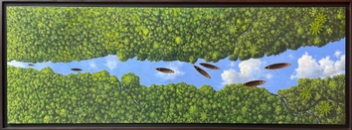 | Pedro Ruiz  Strangers in paradise, 2024  Acrylic on canvas  59 x 150 cm  23 1/4 x 59 in
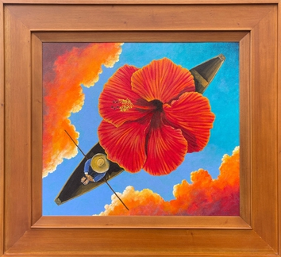 | Pedro Ruiz  Happy, 2025  Oil on canvas  54 x 61 x 3 cm  21 1/4 x 24 x 1 1/8 in
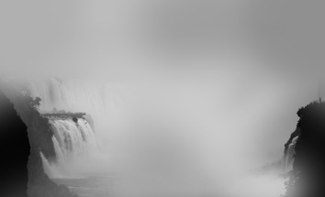 | Mario Arroyave  Travels to the End of the World Series, 2025  Photography  110 x 180 cm  43 1/4 x 70 7/8 in  Edition of 3 plus 2 artist's proofs
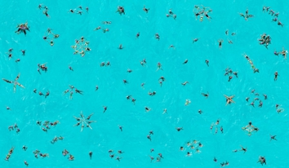 | Mario Arroyave  Synchronized Swimming 2 - Time Line Series, 2025  Gicleé Print on Conservation Paper  110 x 180 cm  43 1/4 x 70 7/8 in  Edition of 3 plus 2 artist's proofs
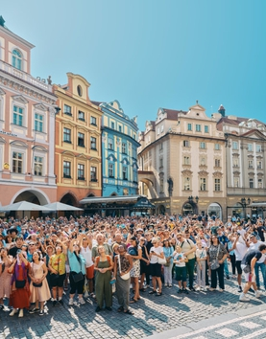 | Mario Arroyave  Prague's Astronomical Clock, 2025  Gicleé Print on Conservation Paper  110 x 90 cm  43 1/4 x 35 3/8 in  Edition of 5 plus 2 artist's proofs
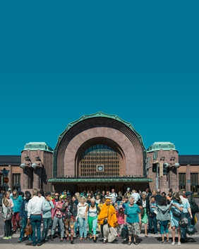 | Mario Arroyave  Helsinki's Train Station, 2025  Gicleé Print on Conservation Paper  110 x 90 cm  43 1/4 x 35 3/8 in  Edition of 5 plus 2 artist's proofs
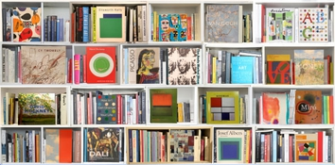 | Max Steven Grossman  Art ZE, 2025  Lightjet print on metallic paper on 3mm dibond  94 x 190 cm  37 x 74 3/4 in  Edition of 5 plus 2 artist's proofs
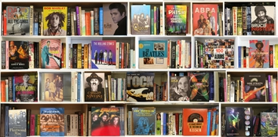 | Max Steven Grossman  Rock AM 2025, 2025  Lightjet print on metallic paper on 3mm dibond  94 x 190 cm  37 x 74 3/4 in  Edition of 5 plus 2 artist's proofs
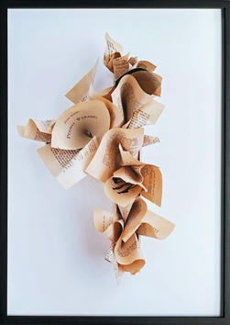 | Jairo Llano  Do You Know Pedro Paramo? , 2022  Digital Print  100 x 70 cm  39 3/8 x 27 1/2 in  Edition of 3 plus 1 artist's proof
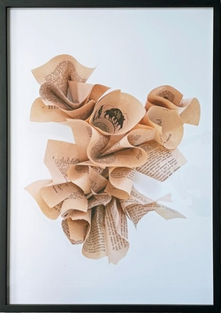 | Jairo Llano  What Have You Found?, 2022  Digital Print  100 x 70 cm  39 3/8 x 27 1/2 in  Edition of 3 plus 1 artist's proof
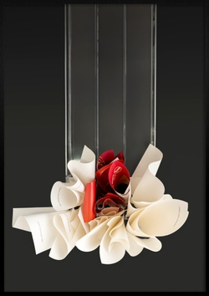 | Jairo Llano  Gravity 2, 2023  Ephemeral paper sculpture, digital photography and print  100 x 70 cm  39 3/8 x 27 1/2 in  Edition of 3 plus 1 artist's proof
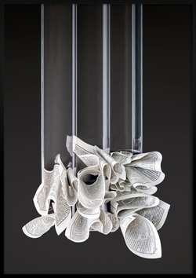 | Jairo Llano  Gravity 1, 2023  Ephemeral paper sculpture, digital photography and print  100 x 70 cm  39 3/8 x 27 1/2 in  Edition of 3 plus 1 artist's proof
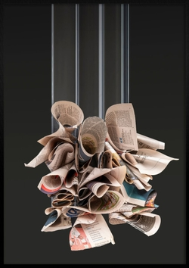 | Jairo Llano  Gravity 3, 2023  Ephemeral paper sculpture, digital photography and print  100 x 70 cm  39 3/8 x 27 1/2 in

