Works available by
18 January 2026

1 | 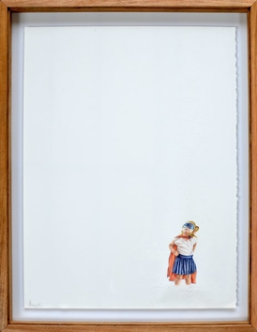 | Pablo Arrazola  Übermensch 24, 2025  Colored pencils on perforated cotton paper  76 x 56 cm  29 7/8 x 22 in
2 | 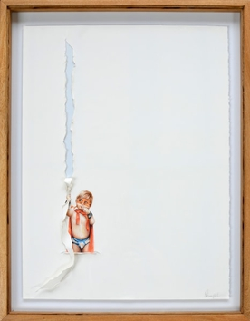 | Pablo Arrazola  Übermensch 31, 2025  Colored pencils on torn cotton paper  76 x 56 cm  29 7/8 x 22 in
3 | 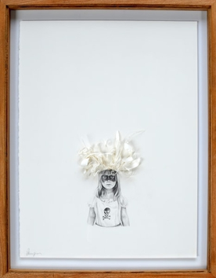 | Pablo Arrazola  Übermensch 34, 2025  Pencil on cut, torn and folded cotton paper  76 x 56 cm  29 7/8 x 22 in
4 | 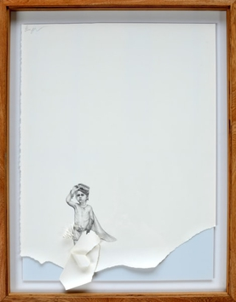 | Pablo Arrazola  Übermensch 37, 2025  Pencil on cut and torn cotton paper  76 x 56 cm  29 7/8 x 22 in
5 | 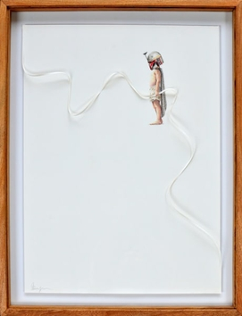 | Pablo Arrazola  Übermensch 40, 2025  Colored pencils on cut and folded cotton paper  76 x 56 cm  29 7/8 x 22 in
6 | 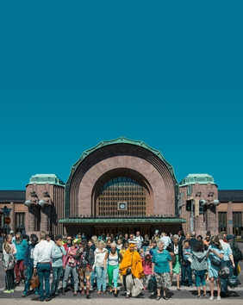 | Mario Arroyave  Helsinki's Train Station, 2025  Gicleé Print on Conservation Paper  110 x 90 cm  43 1/4 x 35 3/8 in  Edition of 5 plus 2 artist's proofs
7 | 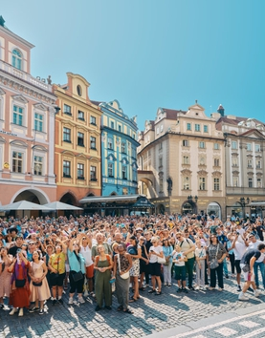 | Mario Arroyave  Prague's Astronomical Clock, 2025  Gicleé Print on Conservation Paper  110 x 90 cm  43 1/4 x 35 3/8 in  Edition of 5 plus 2 artist's proofs
8 | 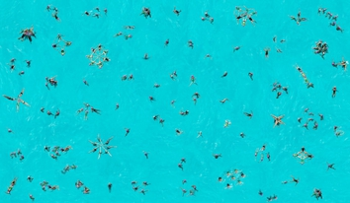 | Mario Arroyave  Synchronized Swimming 2 - Time Line Series, 2025  Gicleé Print on Conservation Paper  110 x 180 cm  43 1/4 x 70 7/8 in  Edition of 5 plus 2 artist's proofs
9 | 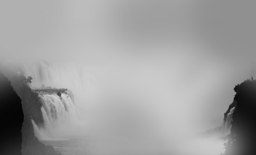 | Mario Arroyave  Travels to the End of the World Series, 2025  Photography  110 x 180 cm  43 1/4 x 70 7/8 in  Edition of 5 plus 2 artist's proofs
10 | 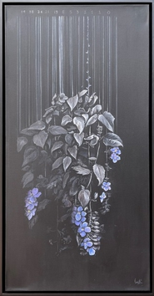 | Camila Echavarria  The Flower of the Bridges, 2025  acrylic on canvas  100 x 50 cm  39 3/8 x 19 3/4 in
11 | 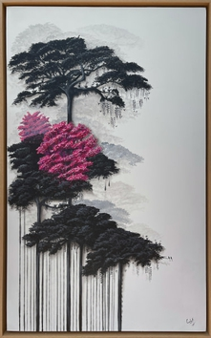 | Camila Echavarria  The Tree I Had Never Seen, 2025  Acrylic on canvas  101 x 61 cm  39 3/4 x 24 in
12 | 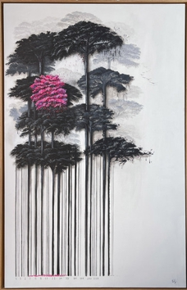 | Camila Echavarria  Jacaranda, 2025  Acrylic on canvas  161 x 101 cm  63 3/8 x 39 3/4 in
13 | 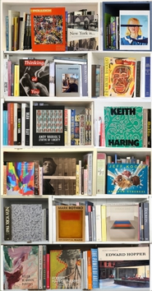 | Max Steven Grossman  Art NYC V, 2025  Lightjet print on metallic paper on 3mm dibond  190 x 100 cm  74 3/4 x 39 3/8 in  Edition of 5 plus 2 artist's proofs
14 | 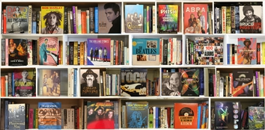 | Max Steven Grossman  Rock AM 2025, 2025  Lightjet print on metallic paper on 3mm dibond  94 x 190 cm  37 x 74 3/4 in  Edition of 5 plus 2 artist's proofs
15 | 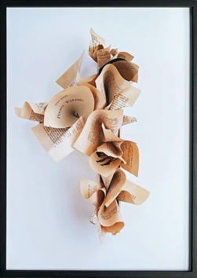 | Jairo Llano  Do You Know Pedro Paramo? , 2022  Digital Print  100 x 70 cm  39 3/8 x 27 1/2 in  Edition of 3 plus 1 artist's proof
16 | 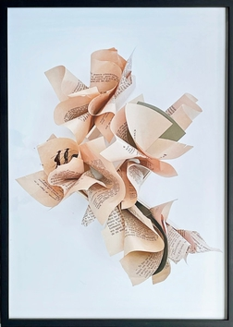 | Jairo Llano  Are You Going to Stay?, 2022  Digital Print  100 x 70 cm  39 3/8 x 27 1/2 in  Edition of 3 plus 1 artist's proof
17 | 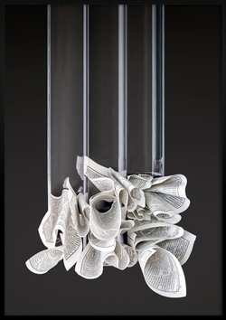 | Jairo Llano  Gravity 1, 2023  Ephemeral paper sculpture, digital photography and print  100 x 70 cm  39 3/8 x 27 1/2 in  Edition of 3 plus 1 artist's proof
18 | 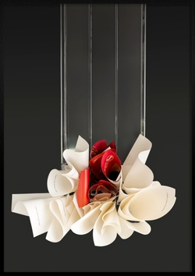 | Jairo Llano  Gravity 2, 2023  Ephemeral paper sculpture, digital photography and print  100 x 70 cm  39 3/8 x 27 1/2 in  Edition of 3 plus 1 artist's proof
19 | 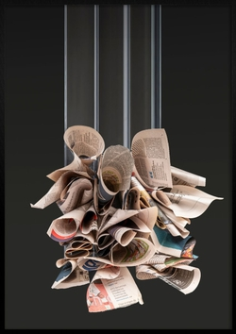 | Jairo Llano  Gravity 3, 2023  Ephemeral paper sculpture, digital photography and print  100 x 70 cm  39 3/8 x 27 1/2 in
20 | 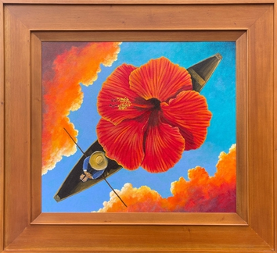 | Pedro Ruiz  Happy, 2025  Oil on canvas  54 x 61 x 3 cm  21 1/4 x 24 x 1 1/8 in
21 | 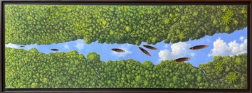 | Pedro Ruiz  Strangers in paradise, 2024  Acrylic on canvas  59 x 150 cm  23 1/4 x 59 in

